Notebook Making with the Crafty Crew – Instruction sheet
Note we are using a traditional book binding skill for this craft session. Anyone who saw the film Little Women recently will have seen it in action towards the end when Jo’s book is made.
You will need:
- Thin card cut to size for the notebook cover
- Paper cut to size for the notebook pages + 1 piece of thin paper cut to the same length as the notebook paper (tonight we’re using 5 sheets, but more can be used in future)
- A bone folder (or ruler)
- A small bulldog clip or a paper clip
- A ruler (optional)
- A pencil
- An awl or other robust object to make holes e.g. a compass
- Cotton
- Scissors
- A candle end for waxing (or a tea light)
- A crewel needle i.e. one with a larger eye for ease of threading
- Beads or similar for decoration (optional)
- Paper and glue for covering the hole in some of the card provided (optional)
For this evening the paper has been cut to size for you already, and a thin piece of paper provided to help with marking the hole placements for your notebook. We are also using mainly pre-folded cards for the notebook cover. Thin card in a variety of designs is available from The Works in Chippenham (or you can upcycle any thin card you get e.g. in the post, or cards where you’ve lost the envelope) if you want to make your own in future.
At home you can cut your paper and card to size using either a paper cutter or a craft knife. A craft mat is also desirable if using the latter. Scissors can be used at a push, but there is a chance the pages won’t quite be the same size! You can decide whether you want the pages to be the same size as the cover or slightly smaller to leave a neat margin inside your book. If you don’t want to do any cutting, then plain A4 card and paper (we used printer paper) is available in the shops for you to make an A5 sized notebook.
This is what you do:
- Take the paper cut to size and fold each piece in half separately, using a bone folder or ruler to make a sharp crease
- Do the same with the thin card (even if it is folded already – the idea is to get the fold crease as sharp as possible)
- Place the papers inside each other to create the pages for your notebook and make sure they are all levelled up neatly
- Take the thin piece of paper and fold it in half, then in half again. Then straighten it out
- Use the fold creases in the thin piece of paper to mark three evenly spaced dots on the middle piece of paper with your pencil (or you can use a ruler to measure and do the same)
- Place the pages centrally inside the notebook cover and hold them in place with the clip provided. Use an awl or similar sharp tool to punch holes through the paper and cover where you marked your dots. You may find a craft mat or similar useful to press down on – not your best table!
- Measure roughly 3 book heights of thread and cut it, then pull the length several times through the edge of the candle part of the tea light (or similar) to wax it
- Thread the needle leaving a small tail
- Decide whether you want the thread ends inside your notebook or on the outside (the latter means you can decorate the threads e.g. with beads if wanted)
- See the diagram below to help with stitching:
  - Start at the centre hole (inside the pages if you’re finishing inside, otherwise start outside as shown in the diagram) and thread the needle through. Leave an end long enough to tie off, or even longer if decorating your thread
  - Push the needle into the top hole and then the bottom
  - Push the needle back into the centre hole and unthread the needle
- Ensuring there is one end of thread either side of the stitched line tie a firm double knot ,then cut off the excess if finishing inside, or cut to the length desired on the outside ready for decoration
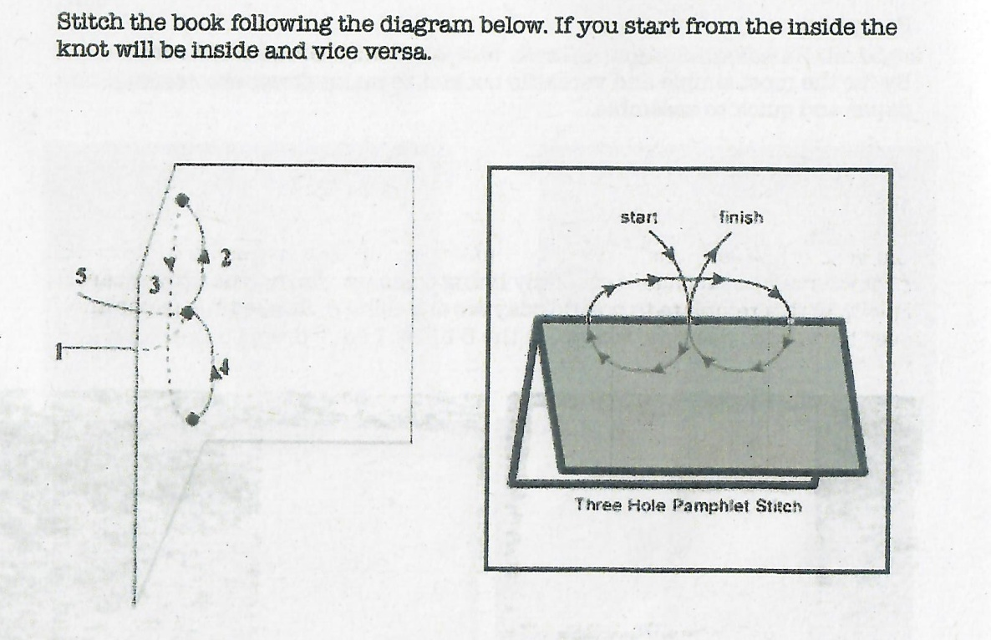
Thanks to April Barlow’s workshop notes at Chippenham Museum for the above diagram

If your cover has a large window hole you can decide to leave it as it is, or decorate the first page to contrast with the cover, or cover the hole from the inside using decorative paper.
There is also the option to decorate your cover in some way, especially if upcycling or using plain card.

